The Cathedral Church of St. Michael and All Angels
St. Michael’s Row, Bridgetown, St. Michael
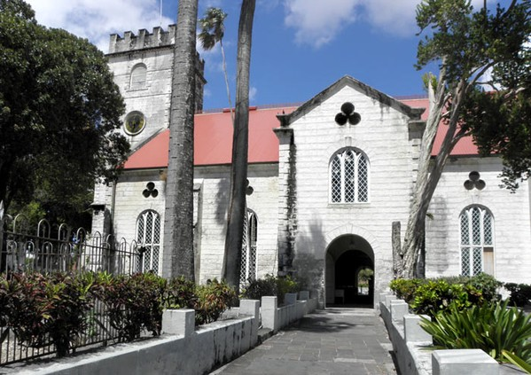

Dean
The Very Rev’d Dr. Jeffrey D. Gibson

Assistant Priests
The Rev’d Canon George Knight, B.Min.
The Rev’d Dr. Marcus Lashley

Assistant Curate
The Rev’d Richard Kellman, LTh.

Seminarian
Mr. Rudolph Dawson

Contact Us:
http://www.stmichaelscathedral.bb
st.michaelcathedral@caribsurf.com
Telephone: 1 (246) 427-0790
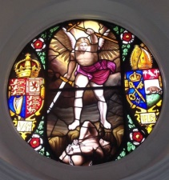
Holy Week and Easter The Cathedral Church
of St. Michael
and All Angels
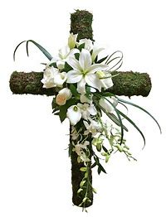
Palm Sunday 25 March
Palm Sunday Eucharist at 7:00 A.M.
with the distribution of Palms
The Liturgy of Palms and Sung Eucharist 8:45 A.M
(The congregation assembles in the
Fairchild Street Bus Terminal
for procession to the Cathedral)

Tuesday, March 27
Holy Eucharist 10:00 A.M.

Wednesday, March 28
Harrison College Founder’s Day Service 9:00 A.M
Chrism Mass 7:30 P.M.

Thursday, March 29
Holy Eucharist ~ Lenten Devotions 12:15 P.M.
The Liturgy of Maundy Thursday 7:00 P.M.
Good Friday, March 30
Family Devotions 8:30 A.M
Choral Matins and Lamentations 10:30 A.M.
The Good Friday Liturgy 12:00 NOON
Solemn Musick for Good Friday 8:00 P.M.

Holy Saturday ~ Easter Eve , March 31
Vigil and Holy Eucharist 6:30 P.M.

Easter Day, April 1
Holy Eucharist 7:00 A.M.
Sung Eucharist 9:00 A.M.
Choral Matins 11: 00 A.M.
Evensong, Procession and the Hallelujah Chorus 6:00 P.M.

